**SUMMARY OF CLINICAL STUDY RESULTS**

|  |  |
| --- | --- |
| * **Sponsor:** | Almirall, S.A. |
| * **Medicines Studied:** | Tildrakizumab and dimethyl fumarate |
| * **Protocol number:** | M-14745-41 |
| * **Dates of the Study:** | 04th September 2019 to 16th February 2022 |
| * **Study Title:** | Treating with tildrakizumab people with moderate-to-severe chronic psoriasis who do not respond to dimethyl fumarate  *(An open-label, randomised, Phase IV study, to assess the efficacy and safety of tildrakizumab in patients with moderate-to-severe chronic plaque psoriasis who are non-responders to dimethyl fumarate therapy)* |
| * **Date of this report:** | 30th September 2022 |

This is a summary of results from one clinical study.

Almirall, the Sponsor, would like to thank all of the participants who took part in this clinical study. All of the participants helped us answer important questions about tildrakizumab and dimethyl fumarate in moderate-to-severe chronic plaque psoriasis. If you have participated in the study and have any questions about the study or results, please contact the doctor or staff at your study site.



**SUMMARY**

**Purpose of the study:**

To assess how well do patients with chronic plaque psoriasis react to dimethyl fumarate (DMF), as well as to tildrakizumab (only if the psoriasis did not improve when taking DMF), in conditions similar to clinical practice.

**What was tested:**

Tildrakizumab and DMF were studied in a two-part Phase 4 study according to its instructions of use. In a Phase 4 study, an already approved treatment (such as DMF or tildrakizumab) is tested in conditions similar to clinical practice in a large number of patients. In Part 1 of the study, all study participants were treated with DMF, and after 4 months approximately, patients who didn’t improve their psoriasis were given tildrakizumab for the rest of the study (Part 2), whereas those with good/acceptable improvement continued to be treated with DMF.

**People taking part:**

189 adults with a diagnosis of moderate-to-severe chronic plaque psoriasis participated in Part 1 of this study across 2 countries (the United Kingdom and Germany). From them, 140 entered Part 2 of the study (130 of them were treated with tildrakizumab).

**Results:**

Tildrakizumab reduced the severity and extent of psoriasis at Week 40 in patients who did not improve their psoriasis after taking DMF. An improvement of psoriasis was seen already at Week 20/24 in patients receiving DMF or tildrakizumab.

**Safety:**

The safety profile of DMF and tildrakizumab was favourable and similar to that seen in previous studies.

**Clinical study identification**

|  |  |
| --- | --- |
| * **Official study title:** | An open-label, randomised, Phase IV study, to assess the efficacy and safety of tildrakizumab in patients with moderate-to-severe chronic plaque psoriasis who are non-responders to dimethyl fumarate therapy |
| * **Simplified study title:** | Treating with tildrakizumab people with moderate-to-severe chronic psoriasis who do not respond to dimethyl fumarate |
| * **Protocol number:** | M-14745-41 |
| * **EudraCT number:** | 2019-000817-35 |
| * **Study name:** | Transition |
| * **Study logo:** |  |

**Name and contact details of the Sponsor**

|  |  |
| --- | --- |
| * **Sponsor:** | Almirall, S.A. |
| * **Address:** | Ronda General Mitre, 151  08022 Barcelona, Spain |
| * **Phone:** | +34 93 291 30 00 |
| * **Fax:** | +34 93 291 35 33 |

**General information about the clinical study**



This summary shows the results from a clinical study where tildrakizumab and dimethyl fumarate (DMF) were tested in moderate-to-severe chronic plaque psoriasis.

## What was the objective of this study?

The objective of the study was to assess how well do patients with chronic plaque psoriasis react to the DMF, as well as to tildrakizumab (only if the psoriasis did not improve when taking DMF), in conditions similar to clinical practice.

## Where was this study conducted?

* The study was conducted in a total of 32 centres, of which only 26 centres recruited patients:
  + **United Kingdom**: 6 patients in 2 centres

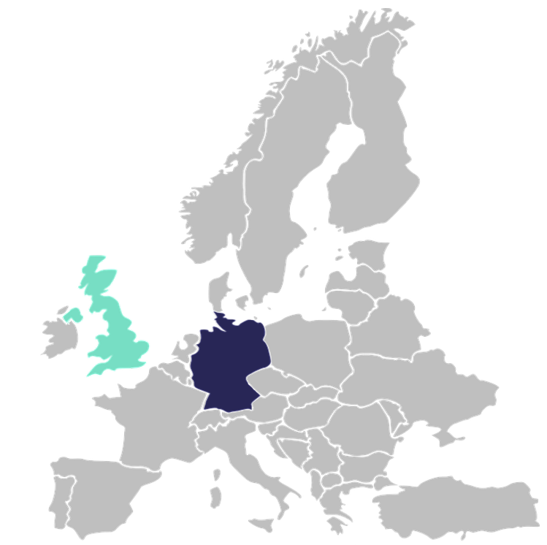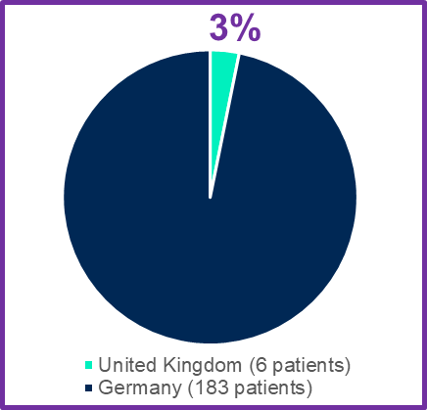

**97%**

**Percentage of patients per country**

**26 centres**

**2**



**24**



**189 patients**

* + **Germany**: 183 patients in 24 centres

## Which was the duration of the study?

* The expected duration of this study was approximately 12-13 months per patient.
* How long each patient was in the study varied, but the entire study lasted about two and a half years.
* The study began on 04th September 2019 and it was completed on 16th February 2022.

## Which was the study design?

This was an “open-label” study, which means that both the participants and the researchers knew which medicine was given. The study was done in two parts and included a total of 12 visits (9 on-site visits and 3 virtual visits). Part 1 included a Screening Period of 4 weeks and the first 16 weeks of the Treatment Period. Part 2 included the last 24 weeks of the Treatment Period and a Safety Follow-up Period.

1. Part 1:

* **Screening Period** (4 weeks; 1 on-site visit): this period comprised one on-site visit where the study doctor checked if the patient was eligible to be included in the study.
* **Treatment Period** (16 weeks; 5 on-site visits + 2 virtual visits): after patients were confirmed as study participants, they entered in Part 1 of the Treatment Period. During this time, patients were asked to come to their doctor’s centre 5 times. During this period there were also 2 virtual telephone visits.

**Treatment in Part 1**

During Part 1, all patients were treated with DMF (following the DMF package leaflet). In the United Kingdom all patients received DMF in a standard scheme. In Germany, patients could have received DMF in a standard or a simplified scheme (both treatment groups received DMF at the same amount, but the simplified version sought to facilitate the way that DMF was taken and to minimize possible side effects).

In Germany, the decision of including one patient in the standard DMF group or in the simplified DMF group was done by chance using a computer program. Each patient had a 75% probability of being placed in the group following DMF standard scheme and a 25% of probability of being placed in the DMF simplified scheme group.



1. Part 2

* **Treatment Period** (24 weeks; 3 on-site visits): during this period patients were asked to come to their doctor’s centre 3 times.
* **Safety Follow-up Period** (1 virtual visit): a follow-up safety visit was done after the last study medicine dose (4 weeks after the last DMF dose or 17 weeks after the last tildrakizumab dose). This was a virtual telephone visit.

**Treatment in Part 2**

After seeing how much the psoriasis was improved at Week 16, patients continued to be treated with DMF or changed to tildrakizumab during Part 2.

The improvement of psoriasis was evaluated using the PASI score. PASI is an acronym for Psoriasis Area and Severity Index, which is a widely used tool in psoriasis studies that assesses the severity of psoriatic lesions and the patient’s response to treatment.

In this part, patients continued with DMF if the improvement of psoriasis was good or acceptable (i.e., achieved a response of at least PASI 50), or started receiving tildrakizumab if the improvement of psoriasis was very little (i.e., did not achieve a PASI 50 response).



The figure below shows what happened during the study to patients located in the United Kingdom (A) and to patients located in Germany (B):

1. **United Kingdom**

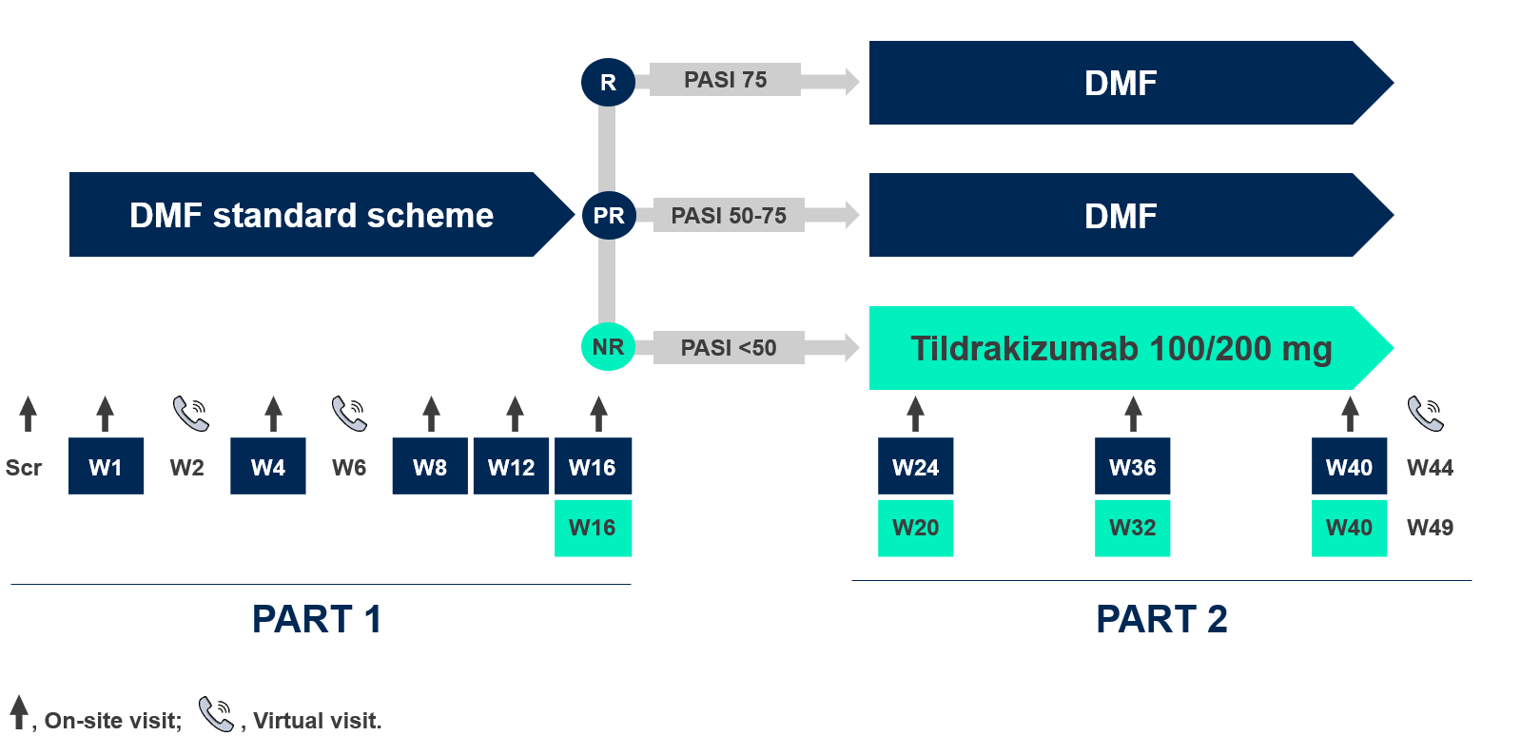

1. **Germany**

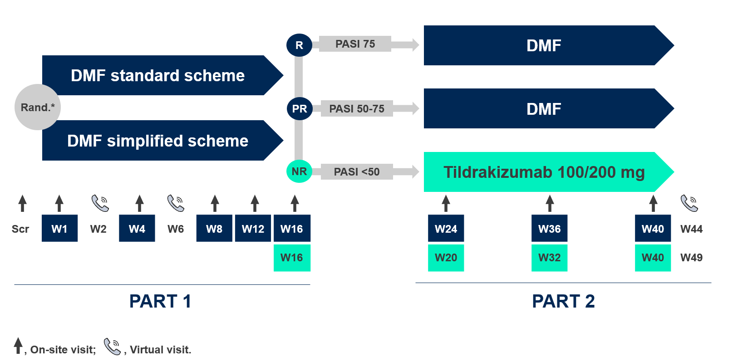

* In Germany, eligible patients were assigned by chance to the DMF standard scheme (75% of probability) or the DMF simplified scheme (25% of probability).

DMF, Dimethyl Fumarate; NR, Non-responder; PASI, Psoriasis Area and Severity Index; PR, Partial Responder; R, Responder; Rand, Randomization; Scr, Screening; W, Week.

Patients achieving a PASI response of 75 or greater at Week 16 were considered responders to treatment (i.e., good improvement of psoriasis) and continued treatment with DMF. Patients achieving a PASI response between 50 and 75 at Week 16 were considered partial responders (i.e., acceptable improvement of psoriasis) and continued treatment with DMF. Whereas patients achieving a PASI response below 50 at Week 16 were considered as non-responders (i.e., little improvement of psoriasis) and were changed to tildrakizumab.

**Why was this study done?**



**?**

Tildrakizumab and DMF have been shown to help reducing and improving the red raised scaly patches (plaques) in the skin of patients with psoriasis. Previous studies have demonstrated that the use of both medicines was well tolerated in patients with moderate-to-severe psoriasis.

This study was carried out after tildrakizumab and DMF had been approved for use (meaning that the medicines could already be prescribed by doctors). The purpose of the study was to evaluate how well patients with chronic plaque psoriasis react to DMF, as well as to tildrakizumab (in those patients who did not react to DMF and their treatment was changed to tildrakizumab).

**What patients were included in this study?**



Adults with a diagnosis of moderate-to-severe chronic plaque psoriasis could participate in this study. This study had 189 participants in Part 1 and 140 participants in Part 2:



**PART 1**

**189**

**patients**



**143**

**patients**

**DMF standard scheme**

**DMF simplified scheme\***



**46**

**patients**

*Only in Germany



**PART 2**

**140**

**patients**



**37**

**patients**

**DMF treatment**

**Tildrakizumab treatment**



**103**

**patients**

Only 10 out of 189 patients (5%) in Part 1 and 8 out of 140 patients (6%) in Part 2 were 65 or older. Most patients were in the 18-64 years age group:

|  |  |  |  |  |  |  |  |
| --- | --- | --- | --- | --- | --- | --- | --- |
| **Age group** | **Part 1** | | |  | **Part 2** | | |
| **Standard DMF scheme (n=143)** | **Simplified DMF scheme (n=46)** | **Total Part 1 (n=189)** |  | **DMF (n=37)** | **Tildrakizumab (n=103)** | **Total Part 2 (n=140)** |
| **18-64** | 134 (94%) | 45 (98%) | 179 (95%) |  | 35 (95%) | 97 (94%) | 132 (94%) |
| **≥65** | 9 (6%) | 1 (2%) | 10 (5%) |  | 2 (5%) | 6 (6%) | 8 (6%) |

Percentages are calculated dividing the number of patients in the age group by the total number of patients in the corresponding treatment group and multiplying by 100. The total number of patients in each treatment group is indicated at the top of each column between parenthesis (“n=”).

In Part 1, there were 117 men (62%) and 72 women (38%). In Part 2, there were 87 men (62%) and 53 women (38%).

|  |  |  |  |  |  |  |  |
| --- | --- | --- | --- | --- | --- | --- | --- |
| **Sex** | **Part 1** | | |  | **Part 2** | | |
| **Standard DMF scheme (n=143)** | **Simplified DMF scheme (n=46)** | **Total Part 1 (n=189)** |  | **DMF (n=37)** | **Tildrakizumab (n=103)** | **Total Part 2 (n=140)** |
| **Male** | 92 (64%) | 25 (54%) | 117 (62%) |  | 22 (60%) | 65 (63%) | 87 (62%) |
| **Female** | 51 (36%) | 21 (46%) | 72 (38%) |  | 15 (40%) | 38 (37%) | 53 (38%) |

Percentages are calculated dividing the number of patients (males or females) by the total number of patients in the corresponding treatment group and multiplying by 100. The total number of patients in each treatment group is indicated at the top of each column between parenthesis (“n=”).

**Which medicine was studied?**



The medicines studied in this research study were tildrakizumab and DMF.

Tildrakizumab is an injectable medication which is administered subcutaneously. Tildrakizumab belongs to a group of medicines called interleukin (IL) inhibitors. It works by blocking the protein called IL-23, a substance involved in inflammatory and immune responses, which is present at increased levels in patients who have psoriasis.

DMF is a medicine that has been used for psoriasis in the clinical practice since the 90’s. This medicine is administered orally (by mouth) as tablets.

All patients included in this study received DMF for approximately four months (16 weeks) during Part 1. For patients who entered Part 2, they received DMF or tildrakizumab depending on their improvement on psoriasis at Week 16 according to the PASI score.

**What were the side effects?**



## What is a side effect?

Side effects are unwanted medical events (such as a headache), experienced by patients during the study, that study doctors thought were related to taking the study medicine. By comparing medical problems across many studies, doctors try to understand what the side effects of a medicine might be. In this report, the side effects (i.e., unwanted medical events considered related to tildrakizumab or DMF) occurred during the study are discussed.

## Were there any serious side effects?

A side effect is considered “serious” when it results in death, is life-threatening, requires the patient to go to hospital, prolongs an existing hospitalisation, or causes lasting problems.

During Part 1 of the study, 3 serious side effects were reported for patients involved in this study and were considered related to DMF:

* Gastric ulcer was experienced by 1 out of 189 patients (0.5%).
* Gastroenteritis was experienced by 1 out of 189 patients (0.5%).
* Worsening of psoriasis was experienced by 1 out of 189 patients (0.5%).

No serious side effects were reported for patients involved in Part 2 of this study.

## What other side effects did patients have during the study?

During **Part 1** of the study:

* A total of 327 side effects occurred in the standard DMF group.
* A total of 92 side effects occurred in the simplified DMF group.
* Most common side effects were gastrointestinal disorders:
  + 187 out of 327 side effects (57%) in the standard DMF group.
  + 54 out of 92 side effects (59%) in the simplified DMF group.
* Only 14 out of 143 patients (10%) in the standard DMF group discontinued the study because of a side effect:
  + 9 patients discontinued due to gastric problems
  + 3 patients discontinued due to a decreased level of lymphocytes (specific white blood cells important in protection against infections).
  + 1 patient discontinued due to asthma.
  + 1 patient discontinued due to itchy skin (pruritus).
* Only 2 out of 46 patients (4%) in the simplified DMF group discontinued the study because of a side effect. Both of them discontinued due to gastric problems.

The most common side effects reported for patients included in Part 1 of the study are listed below:

**DMF standard (n=143)**

**Blood and lymphatic disorders**

* Low lymphocytes count
* Abdominal pain
* Abdominal pain upper
* Diarrhoea
* Gastrointestinal disorder
* Nausea
* Lymphocytes decreased

Most common side effects considered related to DMF

(reported by more than 4% of patients)

**Nervous system disorders**

* Headache

**Skin and subcutaneous tissue disorders**

* Itchy skin (pruritus)

**Gastrointestinal disorders**

**Investigations**



**Vascular disorders**

* Redness of the skin
* Hot feeling



17 patients (11.9%)

25 patients (17.5%)

34 patients (23.8%)

61 patients (42.7%)

15 patients (10.5%)

12 patients (8.4%)

3 patients (6.5%)

7 patients (15.2%)

14 patients (30.4%)

12 patients (26.1%)

6 patients (13.0%)

4 patients (8.7%)

6 patients (4.2%)

3 patients (6.5%)

7 patients (4.9%)

2 patients (4.3%)

7 patients (4.9%)

2 patients (4.3%)

37 patients (25.9%)

10 patients (7.0%)

12 patients (26.1%)

2 patients (4.3%)

**DMF simplified (n=46)**

Percentages are calculated dividing the number of patients included in Part 1 experiencing a side effect by the total number of patients in the corresponding treatment group and multiplying by 100. The total number of patients in each treatment group is indicated at the top of each column between parenthesis (“n=”).

During **Part 2** of the study:

* A total of 17 side effects occurred in the DMF group.
* A total of 13 side effects occurred in the tildrakizumab group.
* Most common side effects in the DMF group were related to blood and to lymphatic system (whose function is to return fluids from body tissues to central circulation): 8 out of 17 side effects (47%).
* Most common side effects in the tildrakizumab group were related to blood and to lymphatic system (3 out of 13 side effects, 23%) and investigations (3 out of 13 side effects, 23%).
* Only 5 out of 37 patients (14%) in the DMF group discontinued the study because of a side effect. All 5 patients discontinued due to a decrease in the level of white blood cells.
* No patients of the tildrakizumab group discontinued the study because of a side effect.

All side effects reported for patients included in Part 2 of the study are listed below:

* Headache

−

1 patient (1.0%)

* Blood in urine
* Protein in urine

−

−

1 patient (1.0%)

1 patient (1.0%)

* Itchy skin (pruritus)

−

1 patient (1.0%)

* Redness of the skin

2 patients (5.4%)

−

**DMF (n=37)**

**Blood and lymphatic disorders**

* Low white blood cell count
* Low lymphocytes count

All side effects considered related to study treatments (DMF or tildrakizumab)

**Infections and infestations**

* Herpes zoster
* Tonsillitis*

**Investigations**

* CD4 lymphocytes decreased
* CD8 lymphocytes decreased
* Lymphocytes decreased
* Transaminases increased**



1 patient (2.7%)

7 patients (18.9%)

−

3 patients (2.9%)

−

−

1 patient (1.0%)

1 patient 1.0%)

1 patient (2.7%)

1 patient (2.7%)

1 patient (2.7%)

−

**Tildrakizumab (n=103)**

* Vertigo

−

1 patient (1.0%)

**Ear and labyrinth disorders**



* Abdominal pain
* Inflammation of the colon
* Diarrhoea
* Nausea

1 patient (2.7%)

1 patient (2.7%)

1 patient (2.7%)

1 patient (2.7%)

**Gastrointestinal disorders**



**Nervous system disorders**

**Renal and urinary disorders**

**Skin and subcutaneous tissue disorders**

**Vascular disorders**

−

−

−

−

−

2 patients (1.9%)

−

1 patient (1.0%)

*Inflammation of the lumps of tissue at the back of the throat. **Indicative of problems with the liver.

Percentages are calculated dividing the number of patients included in Part 2 experiencing a side effect by the total number of patients in the corresponding treatment group and multiplying by 100. The total number of patients in each treatment group is indicated at the top of each column between parenthesis (“n=”).

**What were the results of the study?**



## Did tildrakizumab reduce the severity and extent of psoriasis at Week 40 in patients who did not improve psoriasis when taking DMF?

The study measured the severity and extent of psoriasis in each patient through the PASI score. PASI is an acronym for Psoriasis Area and Severity Index, which is a widely used tool in psoriasis studies that assesses the severity of psoriatic lesions and how well the patient’s response to treatment.

* The PASI score was calculated using the information that the doctor acquired through a physical examination of patient’s psoriasis.
* The PASI score ranges from 0 to 72. A higher score indicates a more severe condition:

|  |  |
| --- | --- |
| **PASI score** | **Interpretation** |
| **0-5** | None to mild psoriasis |
| **6-10** | Moderate psoriasis |
| **11-72** | Severe psoriasis |

* A PASI 50 response represents a 50% or greater reduction in the PASI score from baseline (Day 1 of the study). It is indicative of a clinically meaningful improvement in psoriasis.
* At Week 16, 103 patients who had not improved psoriasis after taking DMF (i.e., did not achieve a PASI 50 response at Week 16), changed to start treatment with tildrakizumab.

**Tildrakizumab treatment**

**DMF treatment**



**Week 16**

**103 patients**

**PASI response below 50**

**No psoriasis improvement**

* A PASI 75 response indicates a 75% or greater reduction in the PASI score from baseline (Day 1 of the study) and it is indicative of excellent disease improvement.
* Achieving a PASI 75 response at Week 40, indicated that tildrakizumab had reduced the severity and extent of psoriasis. A total of 78 out of 103 patients (76%) who were treated with tildrakizumab improved their psoriasis at Week 40.

The percentage of patients treated with tildrakizumab achieving and not achieving a PASI 75 response at Week 40 are displayed below:

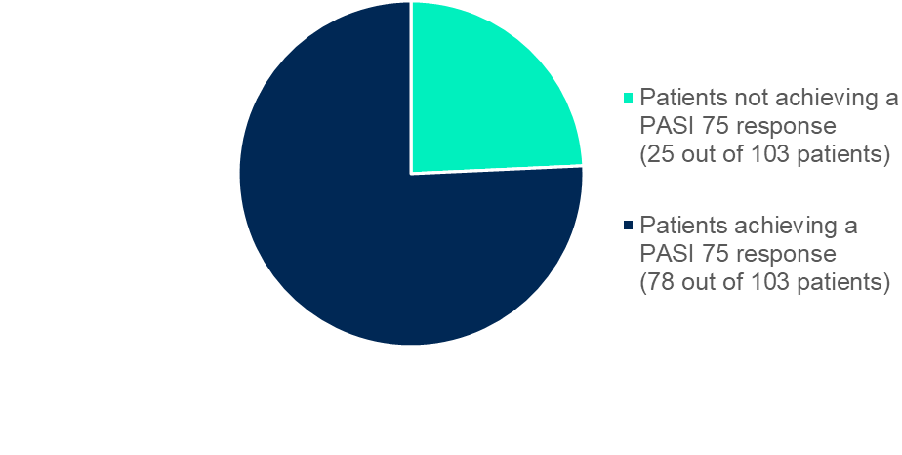

**24%**

**76%**



**103 patients treated with tildrakizumab**

**Week 40**

Tildrakizumab reduced the severity and extent of psoriasis at Week 40, as assessed through the PASI 75 response, in patients who did not improve psoriasis after taking DMF.

## How well do patients with chronic plaque psoriasis react to the DMF and tildrakizumab in similar conditions to clinical practice?

Throughout the study, the severity and extent of psoriasis in each patient were measured through the PASI score.

* As explained above, a lower PASI score indicates that the psoriasis is less severe.
* The percentage of patients achieving a score of PASI 5 or lower, PASI 3 or lower, and PASI 1 or lower are indicative of how well patients respond to treatment.

During Part 1 of the study:

* In the standard DMF group, the proportion of patients achieving PASI 5 or lower was 6.8% of patients (8 out 118 patients) at Week 8 and 25.2% of patients (28 out of 111 patients) at Week 16.
* In the simplified DMF group, the proportion of patients achieving PASI 5 or lower was 10.8% of patients (4 out of 37 patients) at Week 8 and 18.2% of patients (6 out of 33 patients) at Week 16.
* No patient from any treatment group achieved PASI 1 or lower at Week 8.
* At Week 16, 4.5% of patients (5 out of 111 patients) in the standard DMF group and 6.1% of patients (2 out of 33 patients) in the simplified DMF group achieved PASI 1 or lower.

The percentage of patients achieving PASI 5 or lower, PASI 3 or lower, and PASI 1 or lower at different visits of Part 1 are displayed in the figure below:

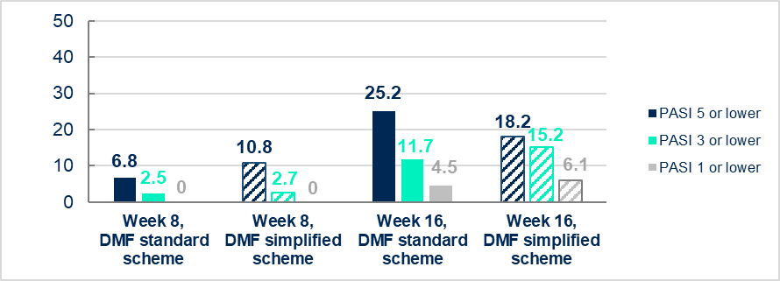

**Percentage of patients (%)**

**Note:** Percentages are based on number of patients reporting data (as observed): Week 8 (DMF standard) = 118 patients, Week 8 (DMF simplified) = 37 patients, Week 16 (DMF standard) = 111 patients, Week 16 (DMF simplified) = 33 patients.

During Part 2 of the study:

* In the DMF group, the proportion of patients achieving PASI 5 or lower was 86.5% of patients (32 out 37 patients) at Week 20/24, 83.3% of patients (25 out of 30 patients) at Week 32/36 and 86.7% of patients (26 out of 30 patients) at Week 40.
* In the tildrakizumab group, the proportion of patients achieving PASI 5 or lower was 30% of patients (30 out of 100 patients) at Week 20/24, 75.7% of patients (78 out of 103 patients) at Week 32/36 and 84.2% of patients (85 out of 101 patients) at Week 40.
* At Week 40, the proportion of patients achieving PASI 1 or lower was 23.3% of patients (7 out of 30 patients) in the DMF group and 45.5% of patients (46 out of 101 patients) in the tildrakizumab group.

The percentage of patients achieving absolute PASI 5 or lower, PASI 3 or lower, and PASI 1 or lower at different visit times of Part 2 are displayed in the figure below:

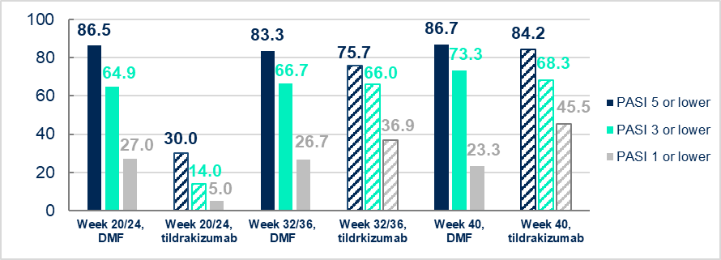

**Percentage of patients (%)**

**Note:** Percentages are based on number of patients reporting data (as observed): Week 20/24 (DMF) = 37 patients, Week 20/24 (tildrakizumab) = 100 patients, Week 32/36 (DMF) = 30 patients, Week 32/36 (tildrakizumab) = 103 patients, Week 40 (DMF) = 30 patients, Week 40 (tildrakizumab) = 101 patients.

The results of this study confirm the improvement of psoriasis in patients taking tildrakizumab who did not improve with DMF in conditions close to clinical practice. An improvement of psoriasis was seen already at Week 20/24 in patients receiving DMF or tildrakizumab.

**Important notice**

This does not mean that everyone in this study had these results. This summary only shows the results from this one study, and more information may be available at the websites listed at the end of this summary. Other studies may find different results, as well.

Researchers look at the results of many studies to understand which medicines work and how they work. Changes in your current treatment should not be made based on results from this study without consulting a healthcare professional.



**How has this study helped?**



Results from this study confirmed the reduction of severity and extent of psoriasis, with a good safety profile, after treatment with tildrakizumab in patients who did not improve their psoriasis with DMF. These findings, obtained in conditions close to clinical practice, support results from previous studies, which were investigated in well-defined and controlled settings.

Overall, this study provides further evidence to continue using tildrakizumab according to its instructions of use for the treatment of adults with moderate-to-severe plaque psoriasis who do not improve their psoriasis with DMF.

**Where can I find more information about this study?**



If you have participated in the study and you have questions about the results, please speak with the doctor or staff at your study site. For more information about this study, please visit:

|  |  |
| --- | --- |
| **Web page** | **Details** |
| **www.clinicaltrialsregister.eu** | Search for EudraCT number: 2019-000817-35 |